|  |
| --- |
| C:\Users\Tsubaki Yukino\Desktop\FlyAwayPlus Project\Capture.JPG |
| **FLY AWAY PLUS** |
| **User Manuals** |
|  |
| |  |  |  | | --- | --- | --- | | **Fly Away Plus** | | | | **Group Members** | Hoàng Nghĩa Đức | SE02882 | | Dương Thanh Hải | SE02856 | | Nguyễn Minh Hoàng | SE02819 | | Trần Mạnh Hiếu | SE02778 | | Phan Tiến Lực | SE02923 | | Lê Minh Thúy | SE02881 | | **Supervisor** | Mr. Nguyễn Văn Sang | | | **Project code** | FAP | | |
|  |

**- Hanoi, 05/2015 –**

**RECORD OF CHANGE**

*A-Added; M-Modified; D-Deleted

|  |  |  |  |  |
| --- | --- | --- | --- | --- |
| **Effective Date** | **Change Items** | **A*M, D** | **Change Description** | **New Version** |
| 17/08/2015 | User installation | A | Add new | 1.0 |
| 21/08/2015 | User guide | A | Add new | 1.0 |
|  |  |  |  |  |

*Table 1: Record of change*

**SIGNATURE PAGE**

|  |  |  |
| --- | --- | --- |
| **ORIGINATOR** | Lê Minh Thúy |  |
|  | Developer |  |
|  |  |  |
|  |  |  |
| **REVIEWERS** | Hoàng Nghĩa Đức |  |
|  | Developer |  |
|  |  |  |
|  |  |  |
| **APPROVAL** | Nguyễn Văn Sang |  |
|  | Supervisor |  |
|  |  |  |

Table of Contents

**1.** **INTRODUCTION** 5

1.1. Purpose 5

1.2. Environment 5

1.3. Application Installation 5

1.3.1. Set up Environments 5

1.3.2. Set up Visual Studio 2013 5

1.3.3. Set up Neo4j for Windows 12

**2.** **USER GUIDE** 19

2.1. Overview 19

2.2. Details guidelines 19

2.2.1. Register account 19

2.2.2. Login 19

2.2.3. View Homepage 20

2.2.4. Personal Activities 20

2.2.5. Edit profile 21

2.2.6. Friends 21

2.2.7. Post 22

2.2.7.1. Create a post 22

2.2.8. Wishlist 26

2.2.9. Notifications 27

2.2.10. Chat with friends 27

2.2.11. Look around for places 28

2.2.12. Room 28

# **INTRODUCTION**

This user's manual has been developed to help users better understand the requirements that may apply to use this website by providing them simple step by step tutorials. This manual is intended to help make website's functions more accessible and their associated requirements more understandable to users.

# User guidelines

## Register account

This is the first page which user will see. From this page the user can go to every page they want.

Step 1: Open browser and enter to the address bar: <http://localhost/Home/Index/>

Step 2: The first page which user will see Welcome page, system displays the Register form

Step 3: Enter information and click Register Now button

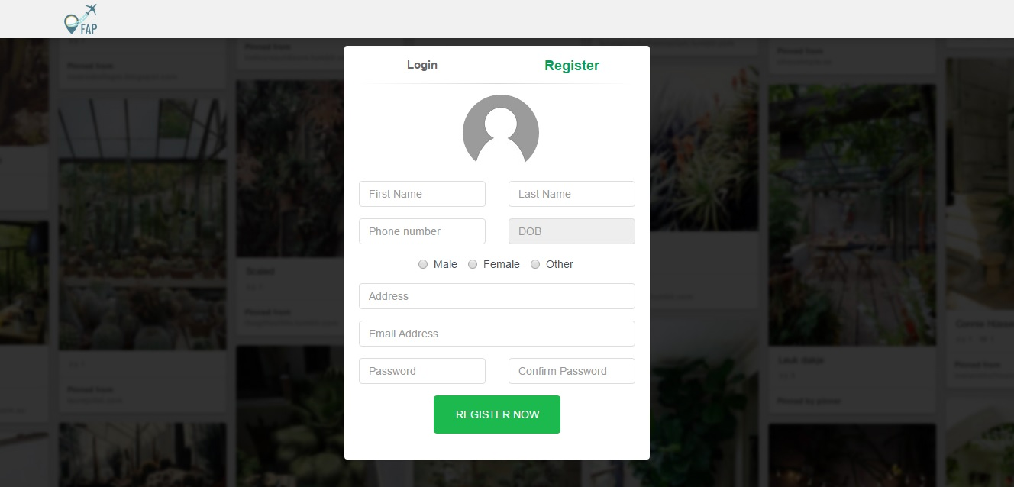

Figure 124: Register account screen

## Login

To use search sentences function on website, the users do the steps below:

Step 1: In Welcome page, system display Login form

Step 2: User enter username and password

Step 3: Click on Login button

Step 4: User can choose Login with Facebook or Login with Google

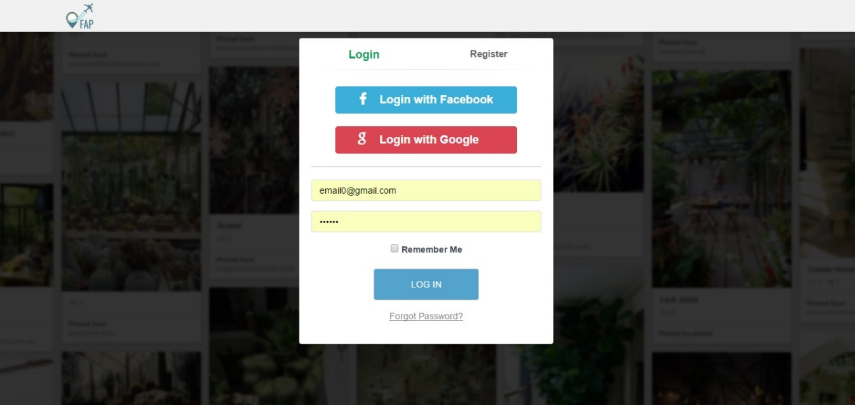

Figure 125: Login

## View Homepage

This is the first page which user will see after login to FAP system. This page display all user’s post, friend’s post and all activity on FAP.

From this page user can use all functions that they want

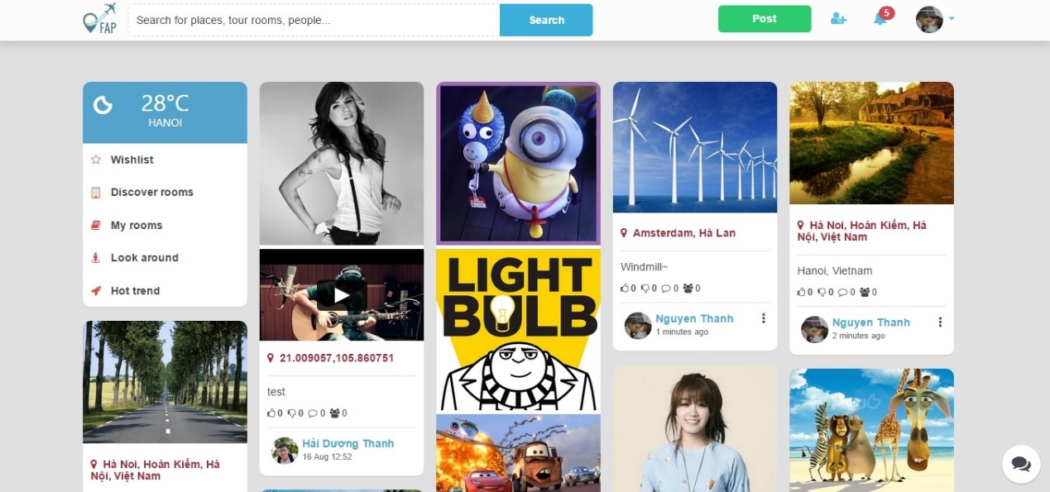

Figure 126: Homepage

## Personal Activities

User can control their own page by clicking on their avatar and select name to redirect to Personal Page.

In this page, all personal activities in personal page is displayed

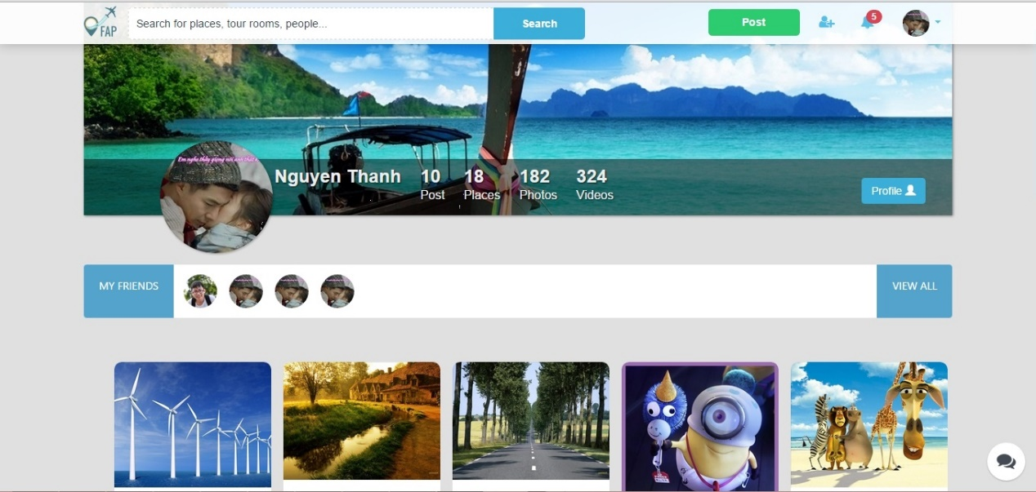

Figure 127: Personal Page

## Edit profile

User can change profile:

Step 1: Clicking on Profile button and clicking on the pencil button on each section.

Step 2: Fill in form and save Personal Profile

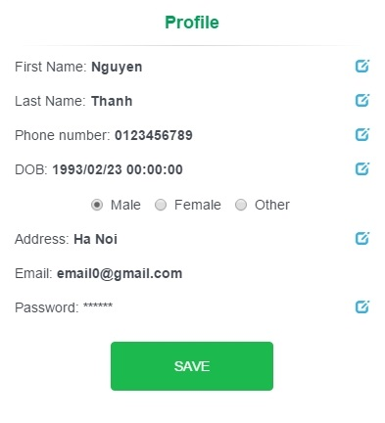

Figure 128: Edit Profile

## Friends

1. User can view friendlist by clicking on Friends section on Personal Page
2. User can view all images of them by clicking on Photo section on Personal Page
3. User can view all video of them by clicking on Photo section on Personal Page

## Post

User can quickly create a post:

Step 1: Clicking on Post button on navigator bar, create post panel will be displayed

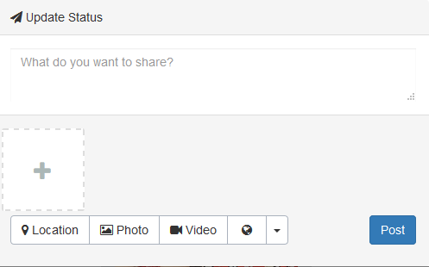

Figure 129: Create a post

Step 2: Choose a location

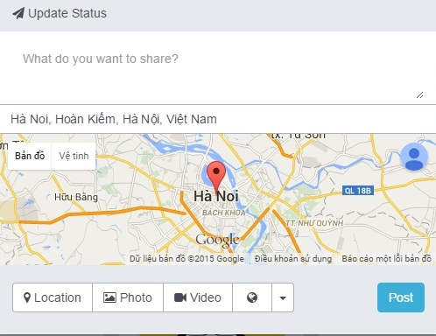

Figure 130: Choose a location

Step 3: Choose Photo(s) by click on + button and click Post

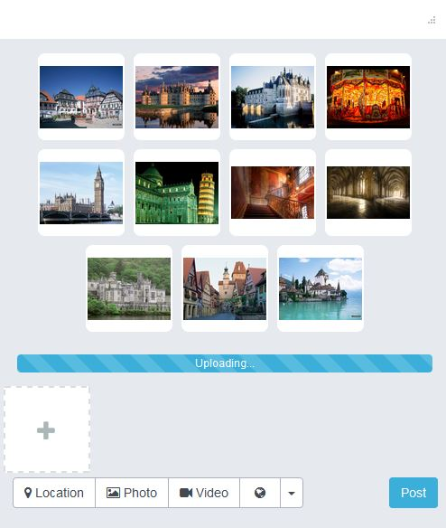

Figure 131: Choose photo(s)

Step 3: Or user can choose video by click on + button and click Post

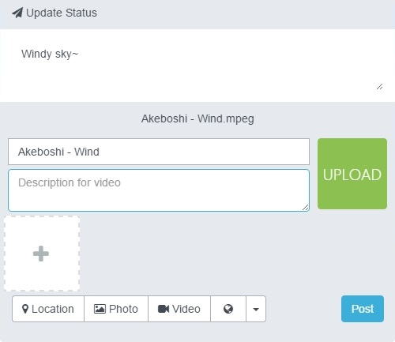

Figure 132: Choose video

User can edit or delete a post

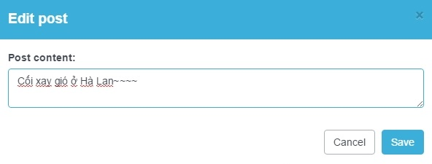

Figure 133: Edit a post

User can view a single post by clicking on them

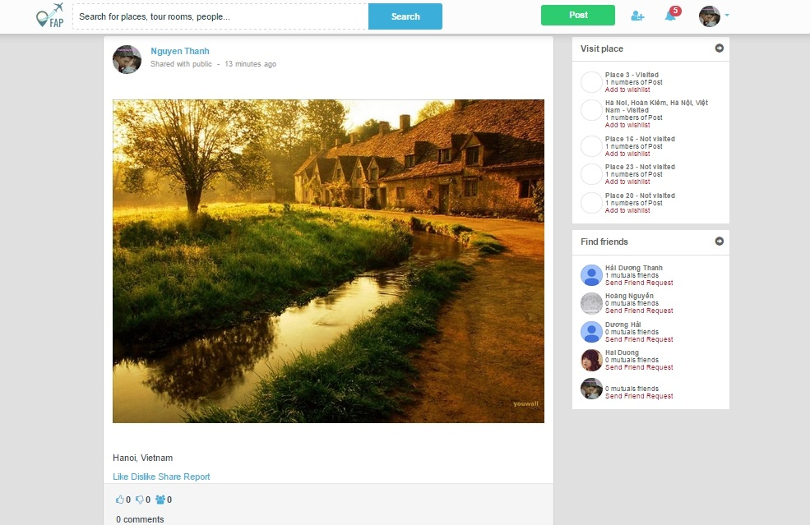

Figure 134: Post details

Watch a video on page

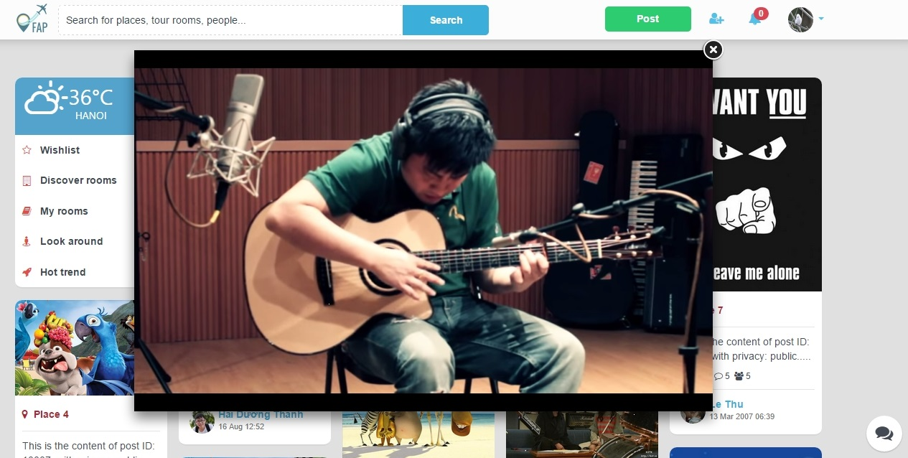

Figure 135: Watch video

User can comment on single post

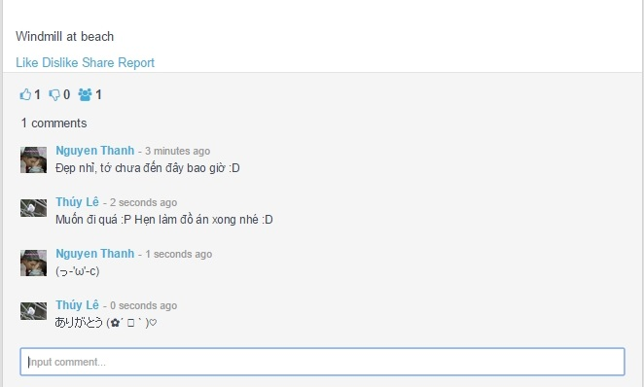

Figure 136: Comment

And share a post to Facebook

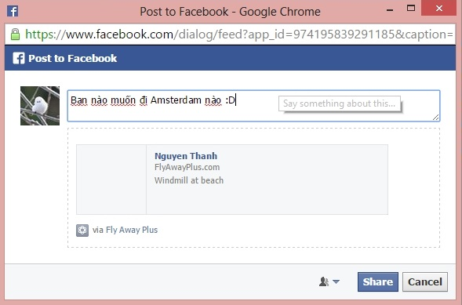

Figure 137: Share to Facebook

User can Like, Unlike, Dislike, Un-dislike a post

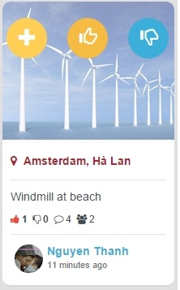

Figure 138: Like

## Wishlist

User can add a place to their wishlist to remember it and remove from wishlist by clicking on C:\Users\Tsubaki Yukino\AppData\Local\TimeSnapper\Snapshots\2015-08-23\15.06.07.945.jpg button on a post

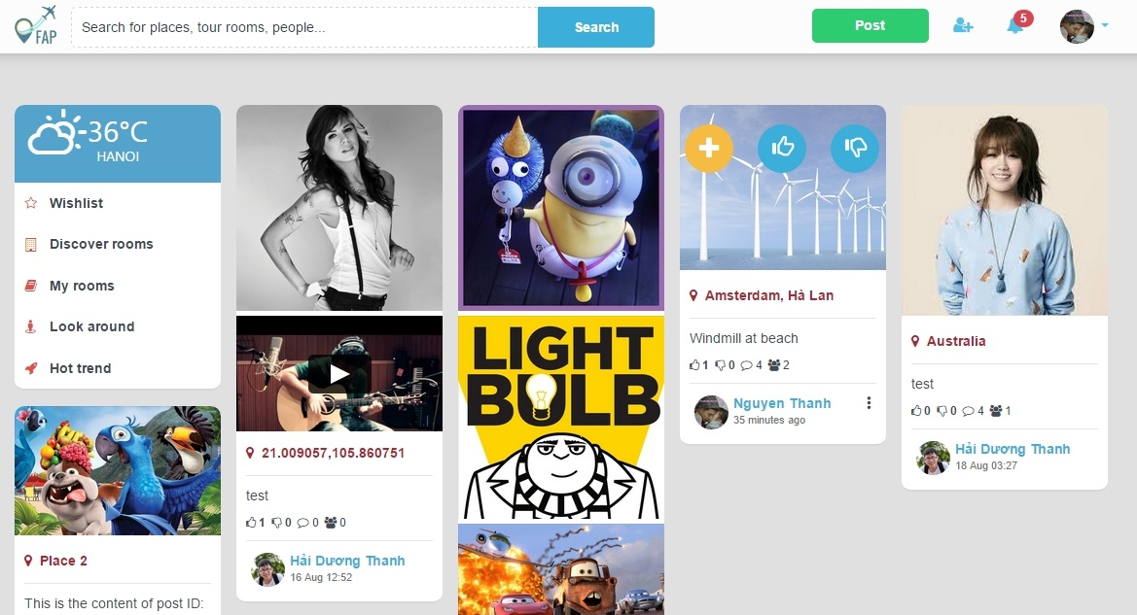

Figure 139: Wishlist

## Notifications

User will be inform by notifications on navigator bar when

* New like, dislike, comments for post
* New friend request

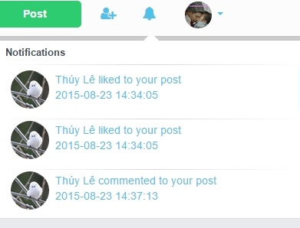

Figure 140: Notification

## Chat with friends

|  |  |
| --- | --- |
|  | C:\Users\Nguyen Minh Hoang\Desktop\Chat.PNG |
| Figure 141: Chat screen 1 | Figure 54: Chat screen 2 |

## Look around for places

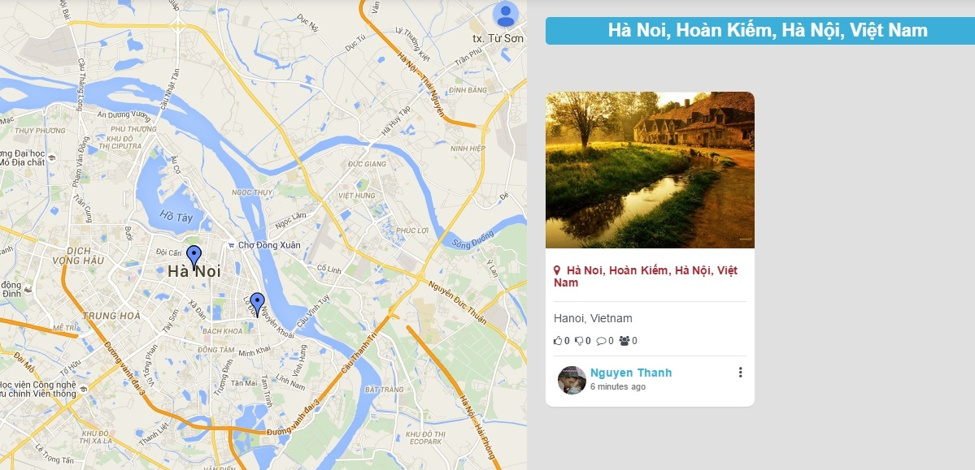

## Room

1. User can search for room on Discover room page:

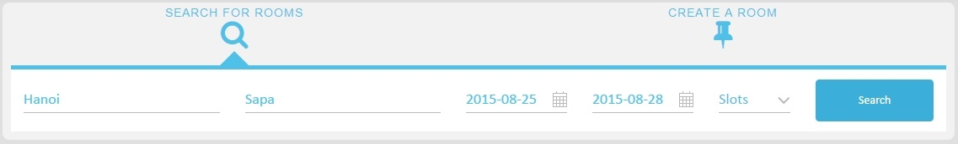

1. Join a room by clicking on a Room thumbnail on Discover Room

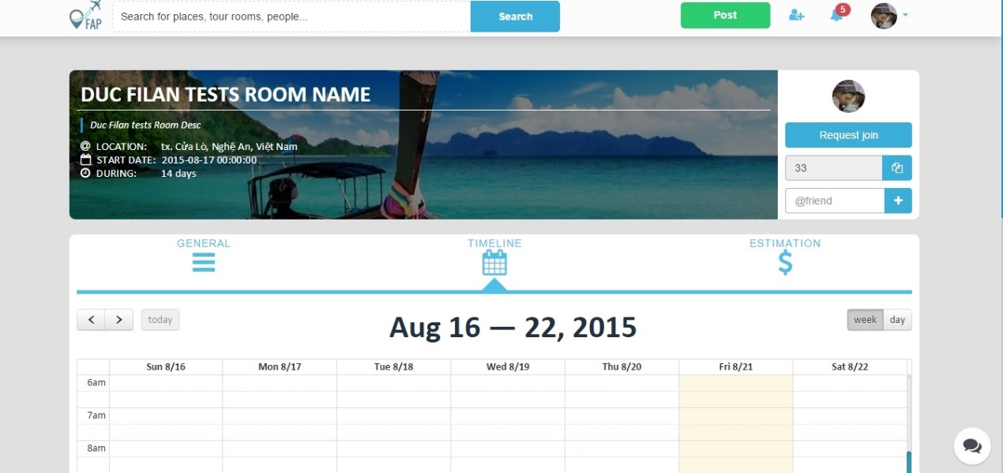

1. Plan a trips

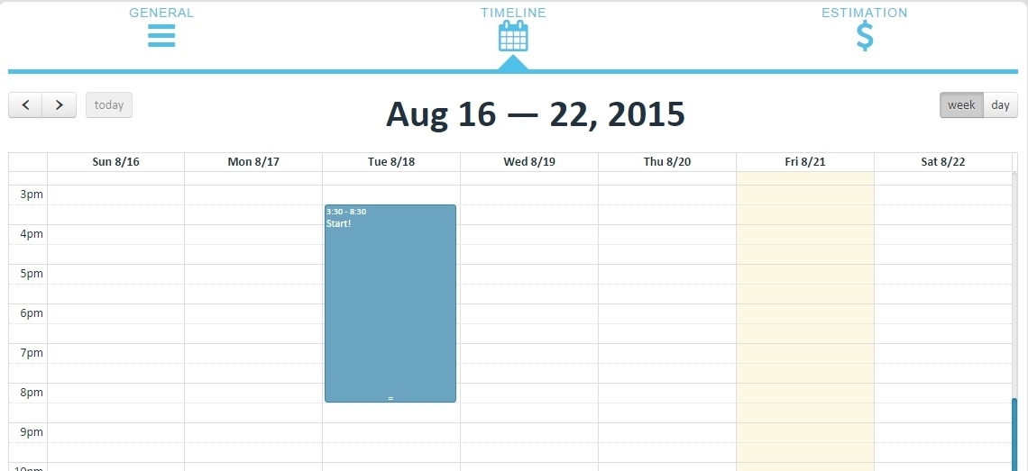

1. Create an event for trips

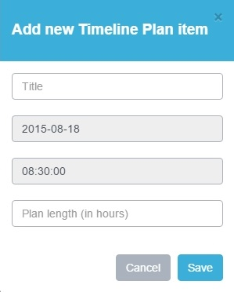

1. User can create their own room:

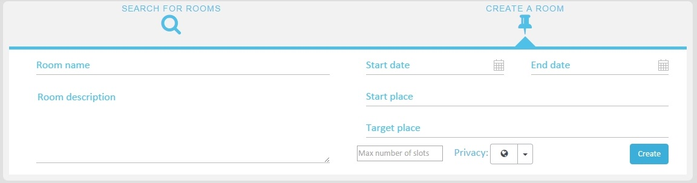

1. Estimate budget of trip

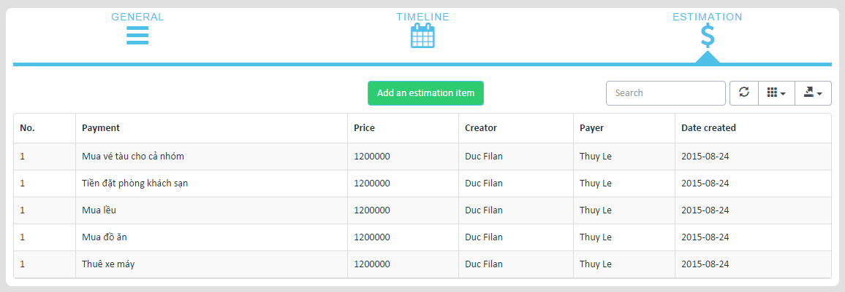

1. Chat with group of friends

## Administrator

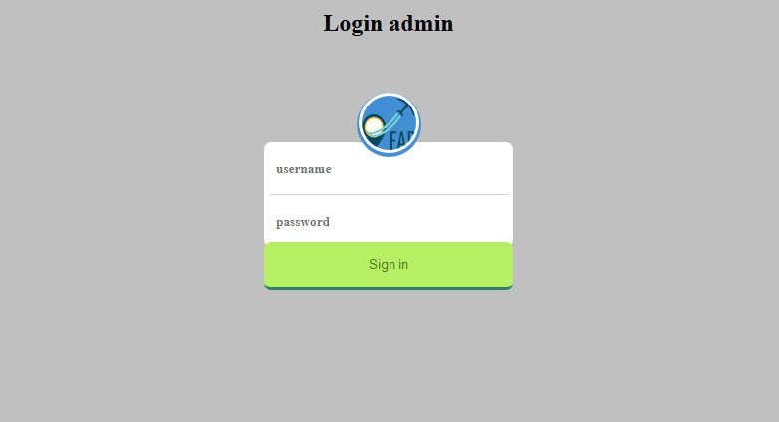

1. Admin login to Admin page to manage system.

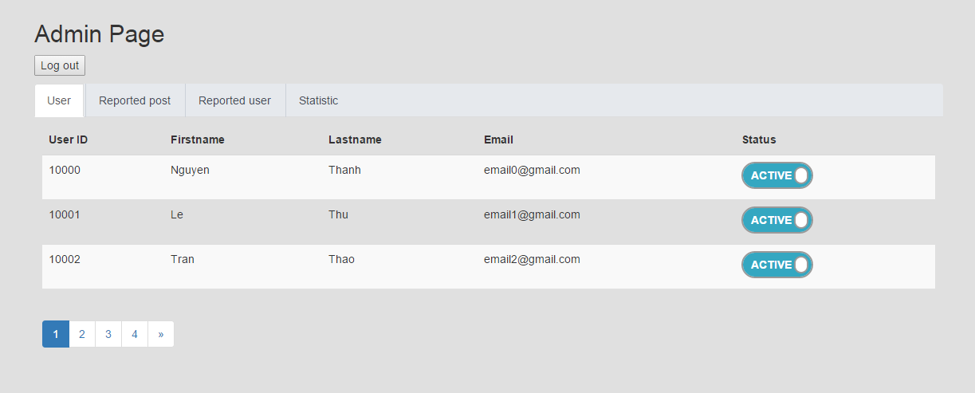

1. Admin clicks Users tab to view all users in system

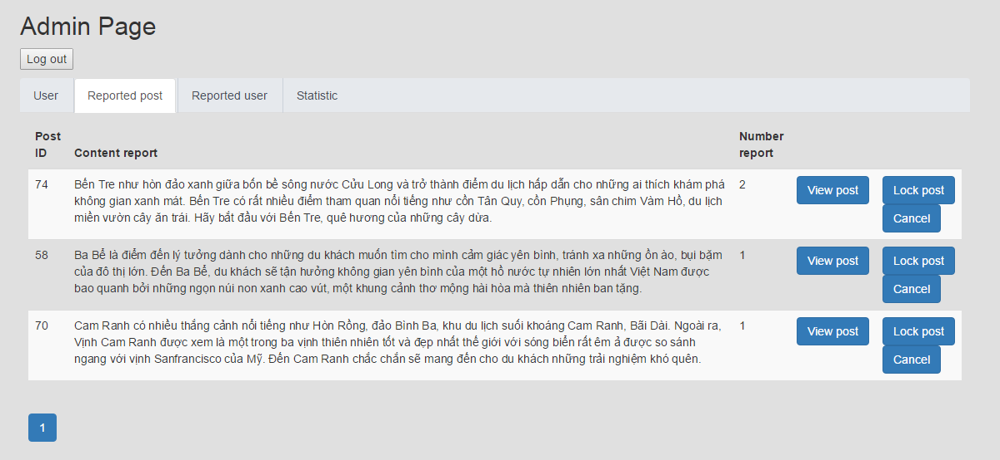

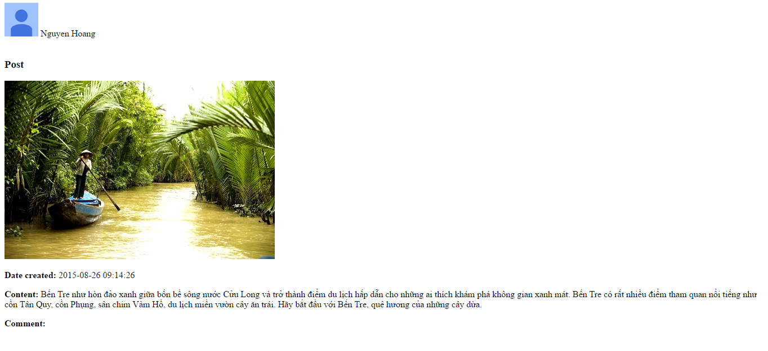

1. Admin clicks Report Post button to view all post which was reported. Admin can view post to confirm that post violate rule of FAP. If that post violate rule of FAP. Admin can click Lock Post. If it isn’t, admin click cancel.

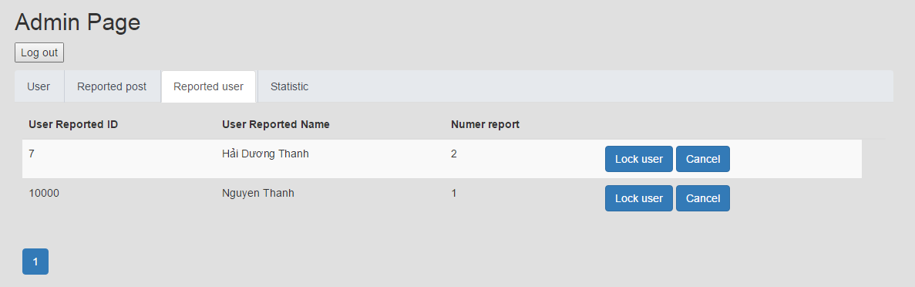

1. Admin clicks Report user button to view all people who has been reported. If user violates rule of FAP admin will using Lock User button.

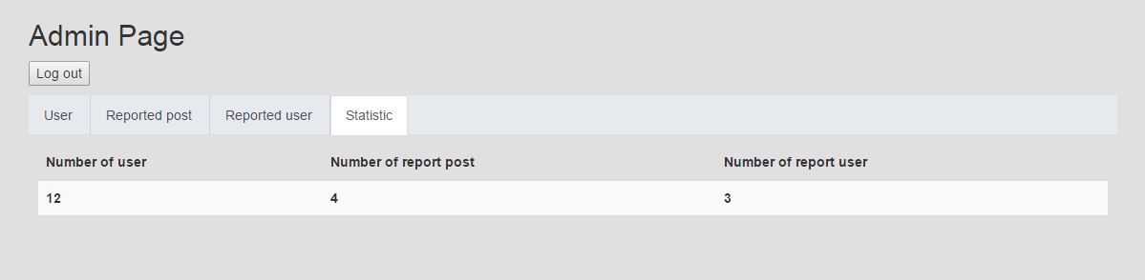

1. Admin clicks Statistic button to view all information about number of users, number of report post and number of report user in here.
2. Admin click logout and exit out of FAP system